STOCKTON SUNDAY LEAGUE
(Founded 1968)

President: Mr D Overton
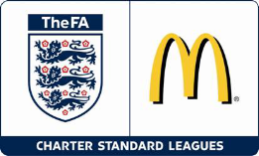

Secretary: Ken Clark Mobile: 07504 303153 Website: www.stocktonsundayleague.org.uk
28 Leicester Road, Norton, Stockton on Tees TS20 2RB Email: Ken.Clark@Stocktonsundayleague.org.uk

F.A & Durham County F.A Charter Standard League

MINUTES OF FIXTURES MEETING 31 July 2013
Held at Elm Tree Social Club

Present : P Mack (Chairman ), P Livingstone (Vice Chairman) , G Hewitson, D Overton, L Golightly, J Lambert, G Eastick, K D Clark (Secretary)

Apologies : A Close, J K Johnson, Jean Johnson, H Oliver

Before the main meeting started the League Chairman Peter Mack (see picture below) presented a cheque for £700 to Valerie Storey of the Chemotherapy Day Unit at North Tees Hospital which was the nominated Charity of Hardwick Social Club in memory of Alex Westwood. This was made up of money raised at the Charity match and the League Presentation Night.

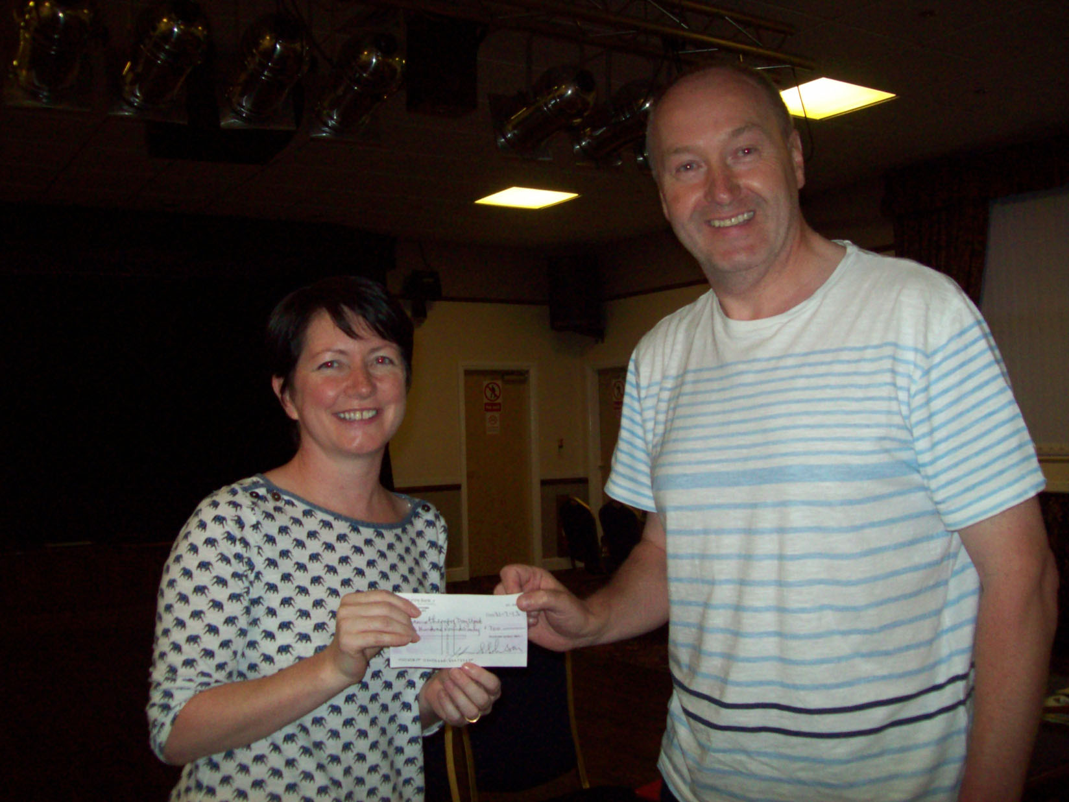

The Chairman then opened the meeting at 7-38 and welcomed all to the first meeting of another new season, he advised that there was quite a lot to get through tonight he then handed over to the League Secretary who advised members that the minutes of the previous meeting April 2013 had been posted on the League website; as these referred to last season there was not really anything of note to carry forward to this season, they were agreed by the meeting and signed by the Chairman.

Secretaries Report & Correspondence

Secretaries Report – Matters Arising

Charter Standard – following on from the April meeting, I attended the Charter Standard Leagues workshop where our Development Plan for the next three years was discussed and approved; we also have had our Charter Standard League Award renewed for the next three years.

Charter Standard

Important Updates
With effect from 1st August FA Learning (FAL) will ONLY accept The FA Emergency Aid (EA) or BFAS certificates as a pre-requisite on FAL coaching courses and for Charter Standard. The reasons for this are twofold:
The content for the course has become even more football specific, with the removal of the Shock and major bleeding topics and the increased prominence given to Asthma and Head injuries/concussion.

The HSE are removing their accreditation of medical courses from September 2013 and Ofqual will be taking their place. There will be a subsequent increase in the number of courses accredited by Ofqual as awarding bodies develop courses to fill the market place. In order to ensure only the most appropriate courses are used as pre-requisites and also to remove any doubt about what qualifications are suitable for FA purposes with the increase in numbers available, we will only be accepting The FA EA certificate.
Read more at http://www.durhamfa.com/news/2013/jul/important-updates-relating-to-fa-emergency-1st-aid-workshops#GHyGJ00KVS92dCeP.99

A First Aid course is to be held on the 23 October 2013 here at the Elm Tree Social Club, there are a number of Clubs whose Certificate has expired or is due to run out so therefore need to make sure they have that person attend the workshop or need to get somebody else qualified. Also need to think about having a second person qualified if this becomes part of the Charter Standard. Clubs whose First Aid Certificate has run out are Billingham Cons, Norton George & Dragon, Stockton Hardwick, Stockton West End, Layfield Arms and The Oxbridge, Malleable’ s is due to run out in October. I have no record of First Aid certificates for Thornaby Oddfellows or Pot & Glass. As stated earlier only FA Emergency Aid certificates will be approved. Please advise League Secretary if your Club requires a place on the First Aid Course by the August meeting, any new team requiring to have somebody attend the workshop please advise League Secretary also.

Just to advise that we are holding a Charter Standard workshop on 28 August 2013 as part of the normal monthly meeting here at Elm Tree, ALL teams are expected to attend. This workshop is to be led by Jeff Russell the Durham County Football Association Referees Development Officer and will look at Respect and Clubs re Misconduct. Just a reminder that ALL teams must attend an in-service workshop as part of their Charter Standard and this is a good opportunity to meet that obligation; the workshop will last no more than one hour and will start at 7-15.

Also this is a reminder to the new teams that they need to start thinking about completing their Charter Standard as we do not want this to drag on, as per league rules this needs to be completed within 6 months.

Correspondence

Letter Durham County Football Association re Sanction of League for Season 2013-2014

Letter Durham County Football Association re Discipline 2013/14 Season (read out)

Secretaries Report

In your envelope tonight you will find a copy of your Team & Division details for all clubs, but check the website for any changes and updates, there are fixtures for August, Septembers have been done but not released yet as the 1 September is the Durham Sunday Cup and the 8 September is the Ian Gorman Memorial Trophy which will be drawn later tonight. Fixtures and Referees for September will be posted on the website once Jes has had time to do these and we have the Durham Cup draw. In an effort to reduce cost the full copy of League Rules can be found on the website, please take time to have a read of these are there are a number of changes as discussed and approved at the Annual General Meeting.

Also in your envelope tonight you will find 10 new match sheets, these need to be filled in before kick-off, exchanged with opponents and a copy to the referee, the game will not kick-off until the referee has his copy, therefore it is the Clubs responsibility to ensure referee has match sheet and the game kicks off on time. Blue copy to Match official, White to opponents and Pink retain by the club until the end of the season, these may be required by the League in cases of dispute.

Please note all Teams need to have submitted their retained list by tomorrow but you can still sign players up until Sunday 4 August 2013 to be eligible to play on the 18 August, these must be with the League Secretary before 5 p.m on that date, any received after this will not be allowed to play on the first Sunday of the season and will be dealt with by the Management Committee as per league rule. ALL teams MUST have a minimum of 14 player registrations submitted by 4 August 2013, along with the correct fee. Just to add that you can still sign a player who was on the retained list once submitted but this will be treated as a new registration. Remember you must have a minimum of 14 player’s registrations submitted by Sunday 4 August 2013.

Can I ask is that you check all details before you submit the forms and make sure you have signed it as well.

Please remember that when you sign a player on the day (from 20 August (the form MUST be signed by a member of the opposing team)) and the details must be sent via text to the League Secretary prior to kick off and the form must be submitted within 48 hours along with the correct fee. The information required is club registering with, the player’s name, address inc post code and date of birth, the reason for this is so that the player concerned will then be covered by the insurance as I have to notify Durham County Football Association of any new signings straight away. Teams will then have to register the player on line when completing the match return, that way I will check against what has been submitted.

The player’s registration slip will not be sent back to the Team Secretary, you need to check the website to see if the player has been registered, normally if there is a problem I will be in touch with team and advise them accordingly. Again you need to make sure the form is fully completed before sending in along with fee. It is your responsibility to make sure a player is eligible to sign before signing especially with match day registrations.

Can I also advise that ALL teams should have returned the Team Agreement Form tonight, if not please be advised that there is a £10 fine for failing to return tonight.

ALL Teams will use the on-line match return again this season and this must be completed by 6 pm on a Tuesday otherwise Teams will be fined for a late return, this must include all the relevant information including red and yellow cards. There is also an additional mark to be awarded this season by a Team to award Respect marks to the opposition’s players, coaches and supporters in line with the FA's recommendations.

For the new Teams this season there is enclosed a leaflet advising of your login details and how to complete the match return, please try login to make sure it works, any problems then give me a ring.

The results will be updated on the Internet and these should be available normally by 7 p.m on a Sunday, some will appear earlier as teams do the online match sheet. The website will again be used to update information so you should check this first for any details such as team numbers or referee’s numbers.

Match Reports will again be submitted to the Evening Gazette and the Northern Echo so I will be looking for reports once more, these need to be submitted to myself preferably by email by 6 p.m on a Tuesday for inclusion in the Gazette on a Thursday evening or the Northern Echo on a Saturday morning in the Local Heroes section. One other way to submit a match report is on the website there is a section called Club Reports, then one called Match Report, this then sends an email to League Secretary.

There is also a report Referee Report, please use this if you have any comments to make regarding a referee, good or bad, the form which must be used when you mark a referee 55 or less, for those who think they will get away with it if the mark is between 56 and 60 they may be request to submit a report.

The important point to remember is to check the website on a regular basis, when I make any changes I will endeavour to send out an email or for them that are not on email I will send a text advising that a change has been made. Therefore if you have an email address and not advised me of it can you let me know as this is the easiest way to let people know or if somebody in the team has an email address you can let me have, then that would be great?

Teams are already asking for games off, to date I have three requests, two for the first game from South Bank and Roseworth Social plus one from Billingham The Kings for the second Sunday. These games are on fixture list tonight, all fixtures will be made available on website, but remember 1 September is subject to Durham Sunday Cup.

A number of Teams have players who have suspensions carried over from last season, these suspensions will begin on Monday 12 August 2013, and however it is each Clubs responsibility to advise their County F.A of those players who are suspended and the games that they will be suspended from. Once players are registered I will update the website with the number of games a player is suspended.

Also a reminder to the Durham County Football Association Clubs to collect the insurance money (£6) from their players, once players are registered I will advise both Durham County Football Association. Once Durham County Football Association invoice the League I will send out to the Clubs and this MUST be paid with 7 days otherwise a Club will be suspended.

Date of the next League Meeting is the General Meeting on Wednesday 28 August 2013

Once again I will put these notes on the website so you can check out anything you have missed or to use as a reminder.

Handbook changes: Went through details supplied, also ask teams to check envelope and website to ensure details are correct, if not please then email League Secretary with correct information.

Team of the Month Award: This will be continued for the coming season.

Cup Draws – The draws for the Ian Gorman Memorial Trophy Preliminary and First round draws carried out as well as the John Jackson Memorial Trophy First Round.

There was a draw for 6 match balls, these were from the Charter Standard League Award and also those not won for Team of the Month. The winners were Billingham The Kings, South Bank, Storytellers United, The Oxbridge, Roseworth Social and The Royal. Congratulations to them all.

The Roll Call was taken and 2 teams were missing, Billingham The Merlin & Market Tavern

There being no further business the Chairman reminded members of the date of the next meeting (28 August) he also advised he would be away for that meeting, he thanked the members for their helpin making the meeting go smoothly he wished all teams the best for the coming seaon and he closed the meeting at 20-15.

Signed: ………………………………………………….. Date: 28 August 2013

